**University of Petroleum and Energy Studies**

School of Computer Science

Department of Cybernetics



**Graphics & Animation Tools**

**LAB FILE**

**(Session: 2020-2021)**

Course: B. Tech with Specialization in Open Source and Open Standards

Batch: 2017-2021

Semester: VIIth

**Submitted By: -**

Akshit Chauhan

Roll No: R100217004

SAP ID: 500062444

**Submitted To: -**

Dr. Durgansh Sharma Assistant Professor

Department of Cybernetics

**Experiment - 4** Design your own animation using GIMP

Step: 1 In the process of a creation of simple animation in GIMP, first we need to draw a simple picture in different frames by the help of Paint program or any tool.

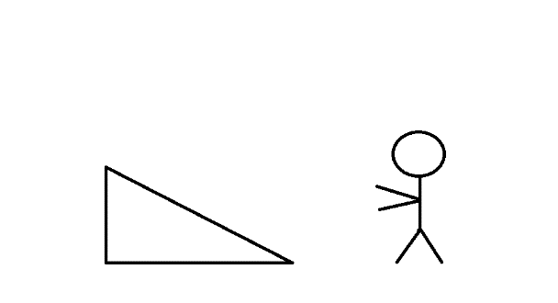

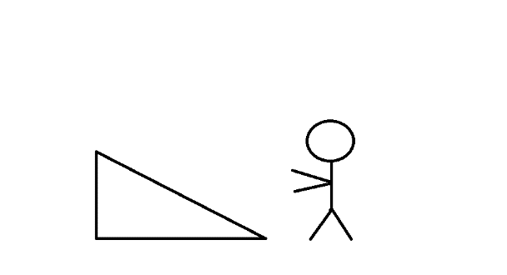

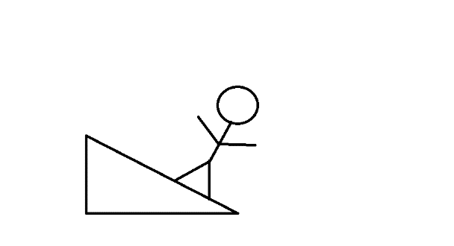

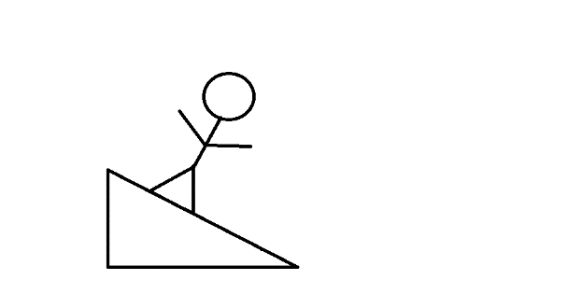

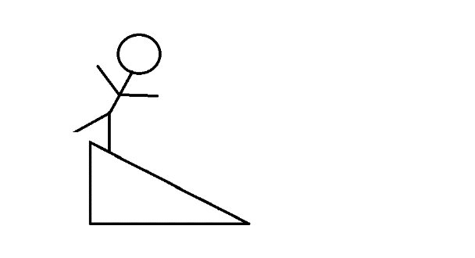

Step: 2 Open GIMP, and go to file->Open As Layers-> And open all the pictures as layers, ordered in chronological order.

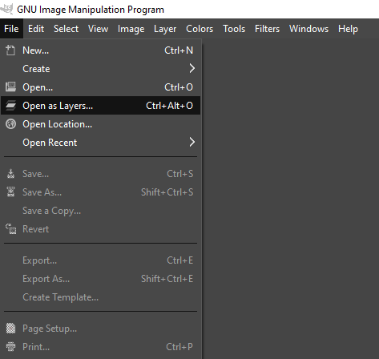

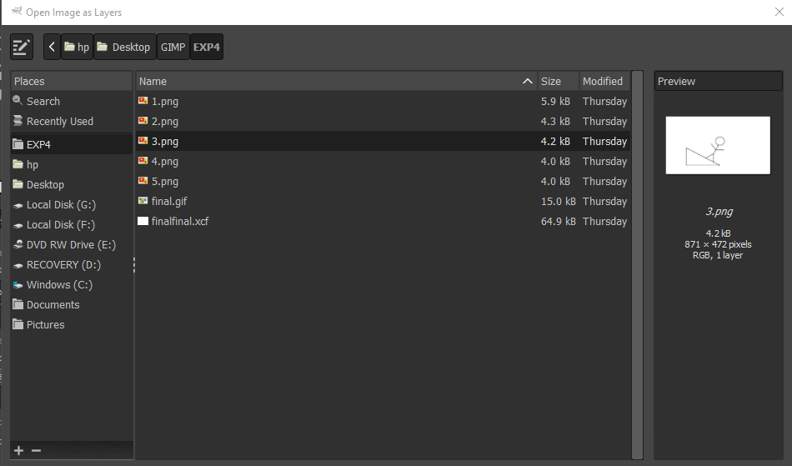

Step: 3 After opening all the pictures as layers, go to export as settings and save the picture in any folder of your choice by the extension .gif. Then export it as animation. Set the delay between frames of your choice in milliseconds.

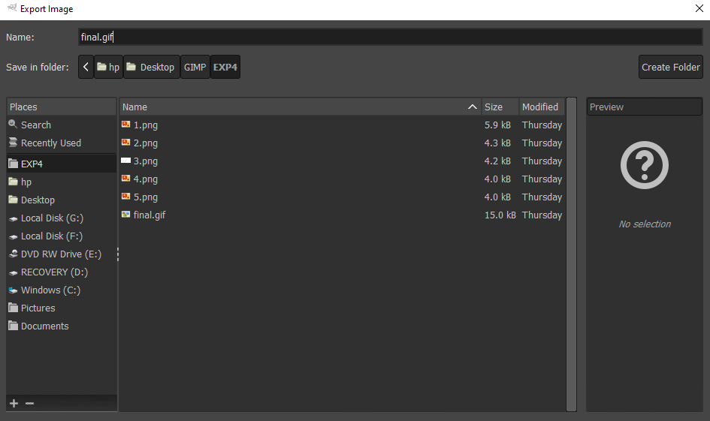

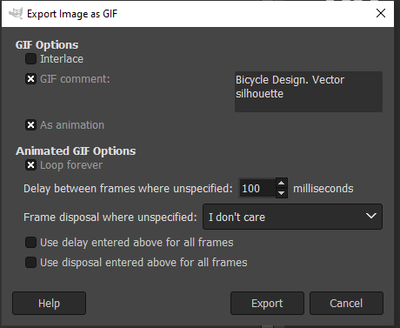

Step: 4 Now open the save file. You’ll see that your pictures of different frames are now converted into one animation as a short GIF.

**OUTPUT:**

